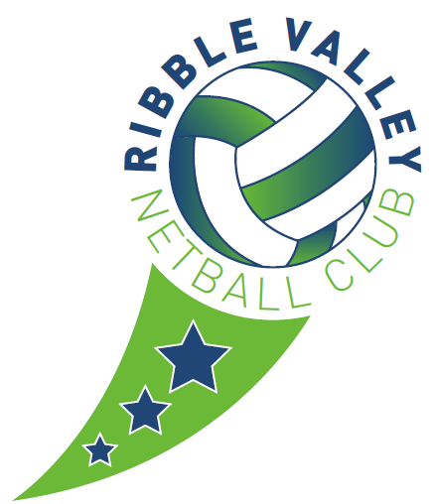
Role outline: Coach / Instructor
NAME OF CLUB: | RIBBLE VALLEY
ROLE: | Coach
RESPONSIBLE TO: | CLUB COMMITTEE
NAME OF VOLUNTEER | Bethany Tomlinson
START DATE: Sept 2021 | END DATE: Aug 2022

Main duties

- To take full responsibility for names sessions (level 2)

- (Level 1) To assist names level 2 Coach to deliver named session.

- To maintain high ethical standards in coaching/instructing, ensure they keep up-to-date with their knowledge, skills and qualifications and prepare all sessions in advance.

- To undertake training appropriate to the role e.g. child protection training.

- To undertake the preparation and running required for each session.

- To attend Coaches club meetings and report on progress.
- To select teams for matches.

- To travel to competitions with the junior team(s).

- To inform the Junior Coordinator in advance of any sessions that cannot be attended.

