Role outline: New Member Appointed Person
NAME OF CLUB: | RIBBLE VALLEY
ROLE: | New Member Appointed Person
RESPONSIBLE TO: | CLUB COMMITTEE
NAME OF VOLUNTEER | Debbie Hallas
START DATE: Sept 2021 | END DATE: Aug 2022
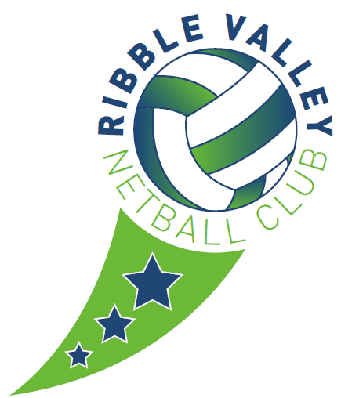
- Regularly check club email for expressions of interest.
- Reply to expression of interest, to acknowledge receipt of email
- Forward expressions of interest to the relevant coach.
- The coach at the session is required to complete the New Member form and pass this to the New Member Appointed Person
- Ensure the coach registers them on Iteammate.
- Liaise with the parent once enrollment at the club is agreed to complete:
  - Go Cardless
  - Code of Conduct - Player
  - Code of Conduct - Parent
  - Club Constitution
- If required, attend the session of the new member to help with; set up of iteammate and England Netball Affiliation.

